In this section, you will now learn how to create and disable Vendor Request and PCard responsibilities on the Oracle Online User Security Request Form.

The Vendor Request responsibility allows users to request the creation of new vendors or vendor sites in the Oracle vendor database.

The PCard responsibility allows a user to review transactions purchased with their Harvard purchasing card.

Both the Vendor Request and PCard responsibilities are listed in the Common Responsibilities section of the Oracle Online User Security Request form.

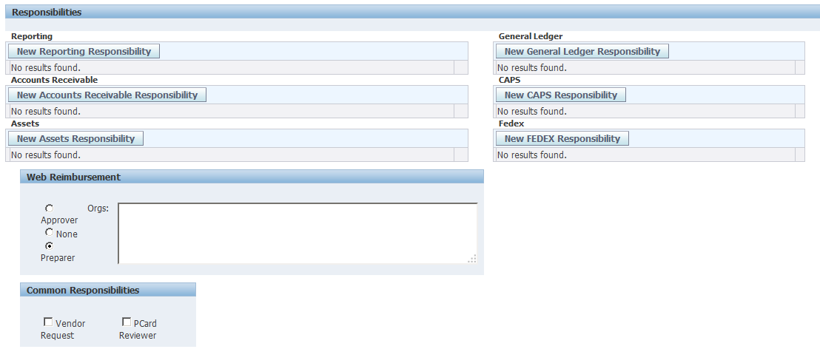

Simply select the checkbox by either or both responsibilities to request user access to these applications.

If a user already has access to either of these responsibilities, then the checkbox(s) will already be selected.

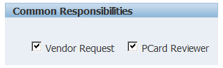

To remove user access to either responsibility, uncheck the appropriate box.

If you wish to add notes about this request to the FSS Client Services Team, scroll down to the bottom of the screen and add your comments in the Comments field.

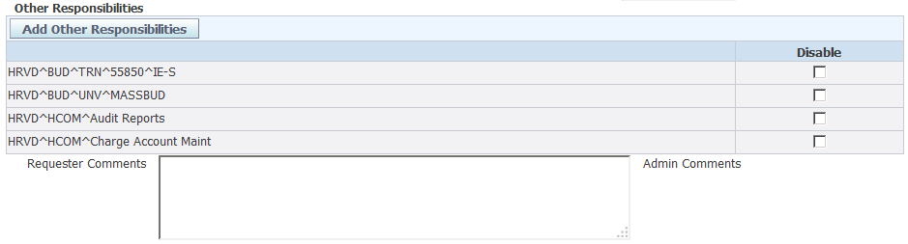
Enter your comments in the Requestor Comments field

If there are no further changes needed for this user, select one of the buttons at the top or bottom of the screen.
There are several options available to you …….
  - If you wish to submit the request, click on the Submit Request button.
  - You can also choose to simply save the form, or Save and Return to the Security Form search screen.
  - You can also Return to the Search screen without saving, or Cancel the request.
  - In this example, Submit Request will be selected.

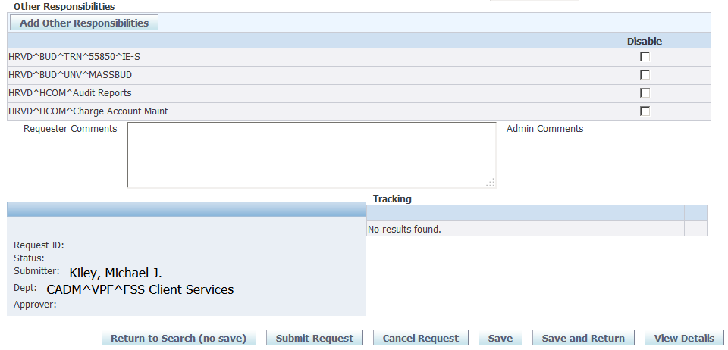

After you submit your request, a confirmation screen will appear.

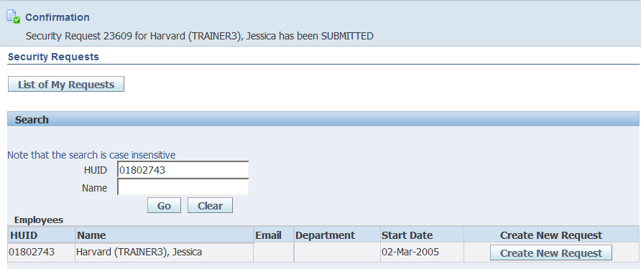

When your request for other responsibilities has been completed, your user will be assigned the responsibilities you requested.

- Vendor Request
- HRVD^PCard Reviewer

