Oracle Responsibility Naming Conventions

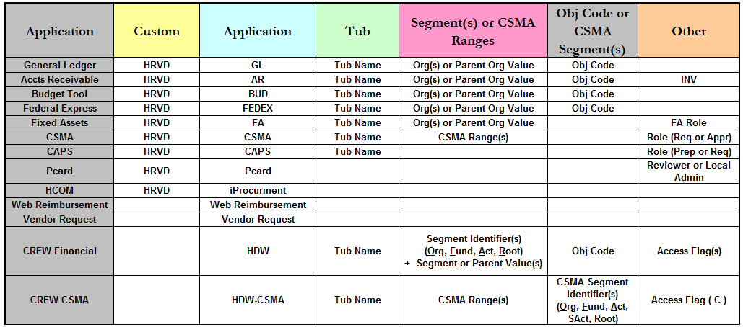

Responsibility Examples

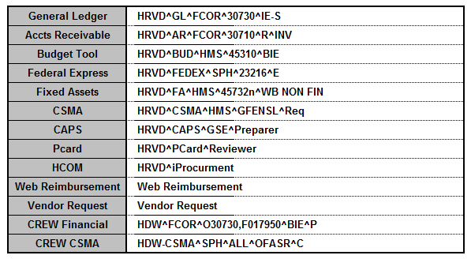

If you have any questions, or need more information, contact Client Services at FSS_Client_Services@harvard.edu.

