In this section, you will now learn how to search for, edit, create and disable Reporting access on the Oracle Online User Security Request Form.

Creating and assigning responsibilities in the Reporting section of the User Security Request form grants users access to the Harvard Data Warehouse (HDW) CREW reporting application.

CREW, Common Reporting Environment for the Warehouse, allows user access to a suite of financial reports. Reports are available in subject areas such as general ledger, budget, CSMA, chart of accounts and user security.

Navigate to the Reporting section of the User Security Request form and click on the New Reporting Responsibility button.

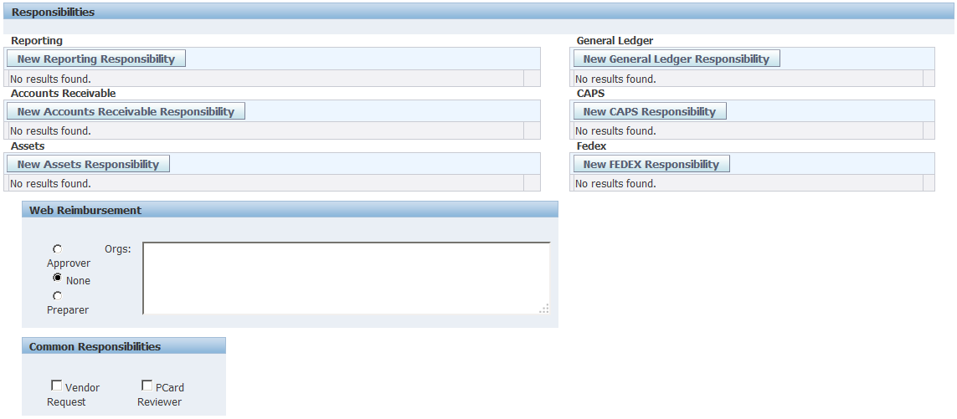

In the new window that opens, you can search for existing HDW reporting responsibilities.

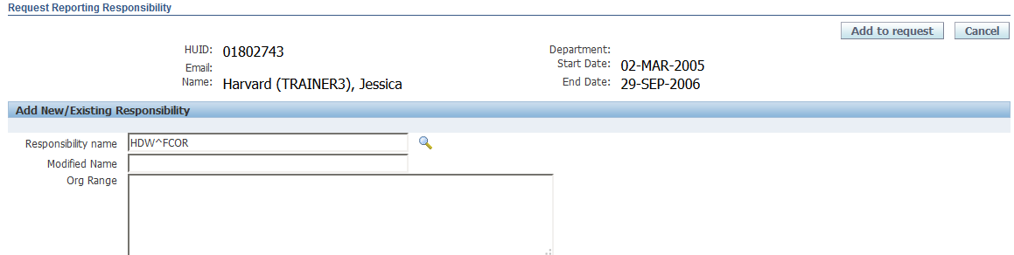
Then click the flashlight icon
To see a list of all current HDW responsibilities:
- Type in the letters HDW, followed by a caret (^)
- Type the 3 or 4 letter acronym for the school or unit

To select an existing responsibility, click on the Radio button in the Select column
Then click the Select button.
- Easier: click the Quick Select icon to select the value.

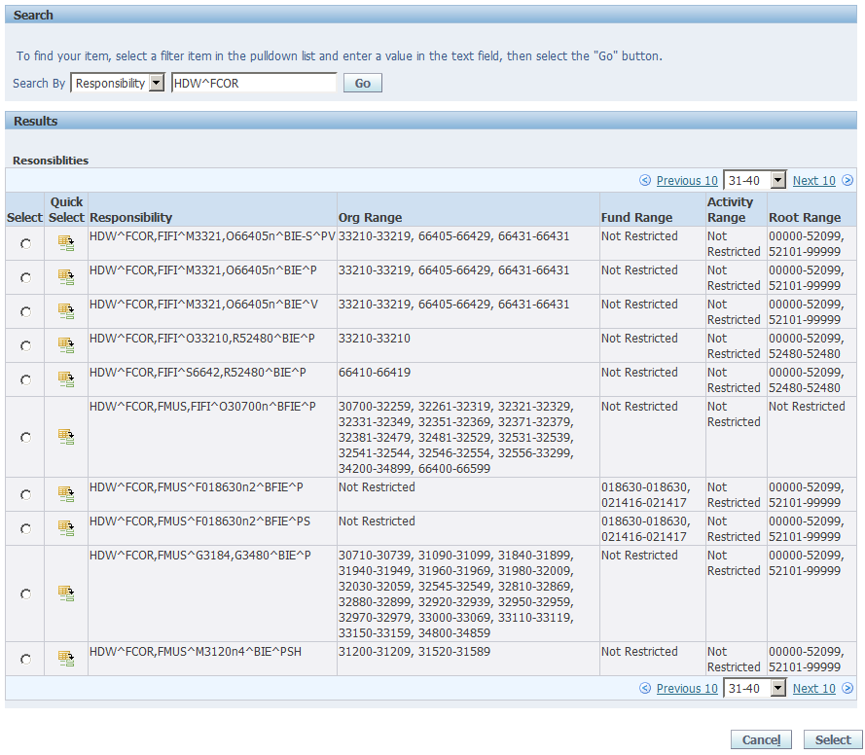

A list of values matching the search criteria will appear on the screen.
- The list begins with the HDW responsibility name. Additional columns displaying the Org, Fund, Activity and Root ranges will appear to the right of the responsibility.
- If there are more than 10 entries on the list, a Next 10 Link will appear on the screen that will allow you to view additional responsibilities.

After selecting a responsibility, you will be returned to the Request Reporting Responsibility screen where the selected Responsibility Name and CoA ranges will appear.

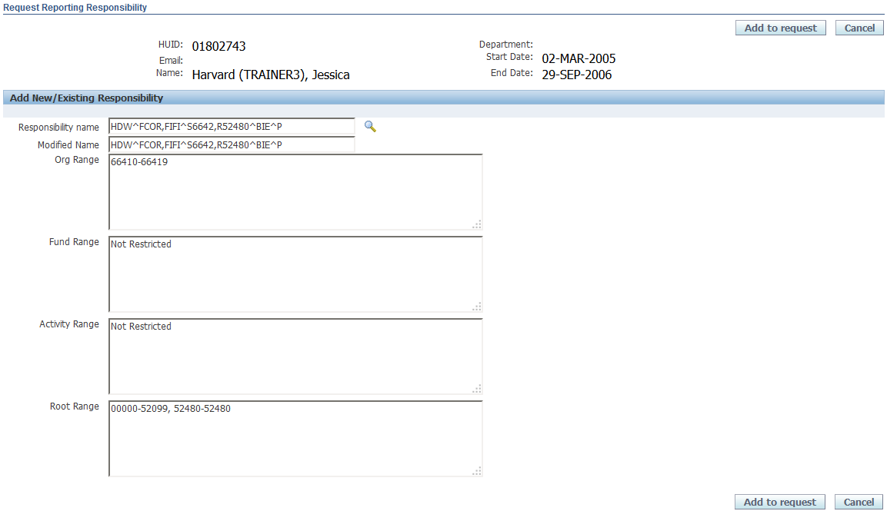

Note that HDW responsibilities may be restricted on a single CoA segment value, or any combination of two of the following CoA segment types, Org, Fund, Activity and Root.

In the example above, the responsibility is restricted on Org and Root values. Other examples could be Org and Fund, Org and Activity, Fund and Root, Fund and Activity, etc.

To add this existing responsibility to your user, simply click on the Add to Request button.

To create a new Reporting responsibility for this user, you can use the existing responsibility and modify it to meet your user's needs.
In this example:
  - The Org value in the responsibility name will be replaced with a new value.
  - The Org values represented by the new Org will be entered into the Org Range field.
.
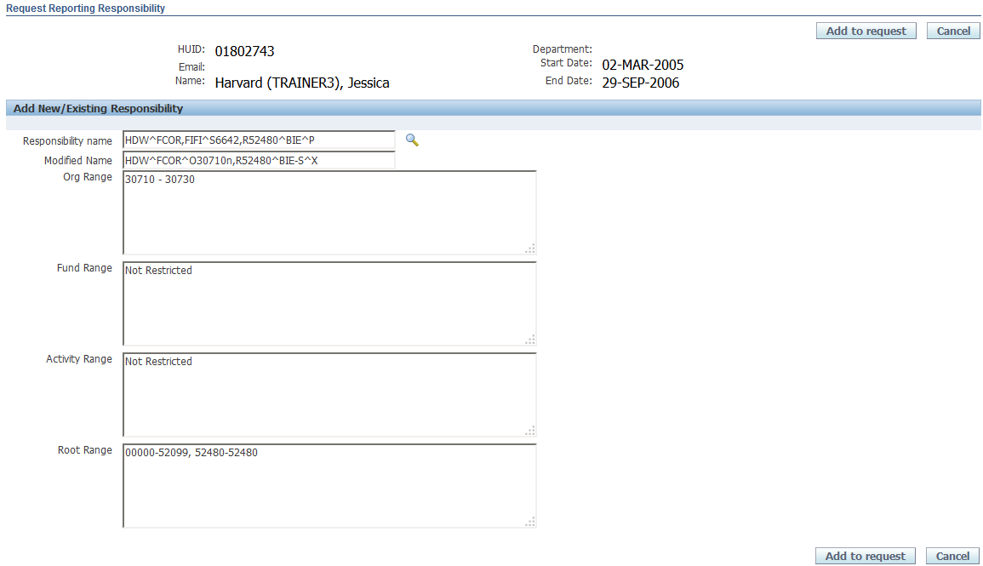
Change the org value in the Modified name field
Enter the modified org range in the Org Range field

Note: A lower case “n” in a responsibility name indicates that the responsibility is restricted on multiple values or range of values, rather than just the single value in the responsibility name (30710n vs just 30710).

In addition to Reporting responsibilities being restricted on various chart values, there are also predetermined object code rules that must also be applied to HDW responsibilities. The letters at the end of a HDW responsibility name identify which object code rules will be assigned,

Some common examples of these object code rules are ……

- BIE – allows balance, income and expense object codes
- BFIE – allows balance forward, income and expense object codes
- IE – allows income and expense object codes
- BIE- S - allows balance, income and expense object codes, less salary object codes
- IE-S - allows income and expense object codes, less salary object codes

For a complete list of object code rules and the values they allow, please see the Oracle Responsibility Object Code Restrictions document in the Oracle User Access section of the Client Services site.

Once you have completed modifying the responsibility name, click on the Add to Request button

When you return to the User Security Form, the responsibility you created will appear in the Reporting Section.
  - Note the asterisk to the left of the requested responsibility. This means that you have added a request but it has not yet been submitted for approval.
  - Click on the Show link to see more details about this responsibility.
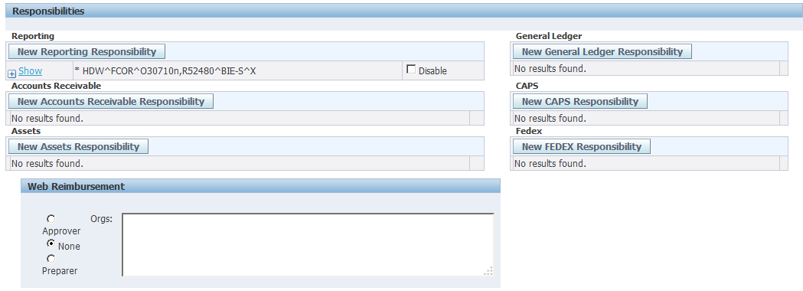

The information regarding the Org Ranges will appear.
  - Close these details by clicking on the Hide link.
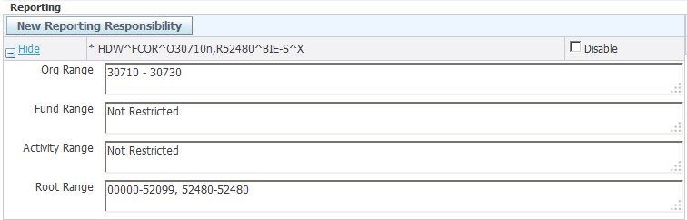

HDW responsibilities also end with a letter called and Access Flag. The most commonly used flags today are the P and X flag.
The P flag indicates that the responsibility will allow a user to view payroll detail.
The X flag indicated that the user will see no additional detail with their responsibility.
A user with a responsibility that ends with BIE^P will see all balance, income and expense object codes, including salary. And the salary transactions will be viewable in detail including employee name and ID number.
A user with a responsibility that ends with BIE^X will see all balance, income and expense object codes, including salary. But the salary will be viewable only in summary with no additional employee detail.

For a complete list of Access Flags and their definitions, please see the Access Flags Definitions document in the CREW User Access section of the Client Services site.

After the request is submitted and approved, this responsibility will be added to the user's security profile.
  - If at any time I want to disable this user's access, you can simply check off the Disable checkbox.
  - If the user leaves the position and/or the University, you can disable all Oracle and Reporting privileges by selecting the Disable User checkbox under the User Access heading.

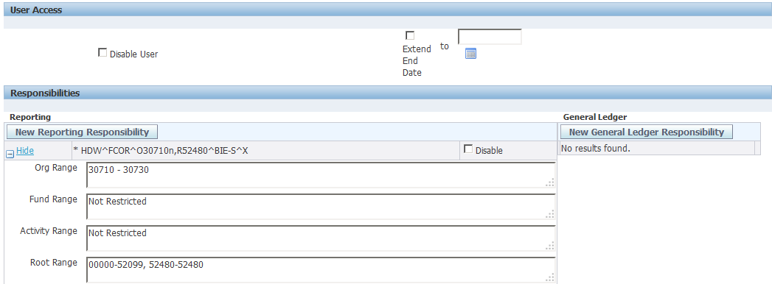
Or just disable the responsibility
Disable the user and all their access

If you wish to add notes about this request to the FSS Client Services Team, scroll down to the bottom of the screen and add your comments in the Comments field.

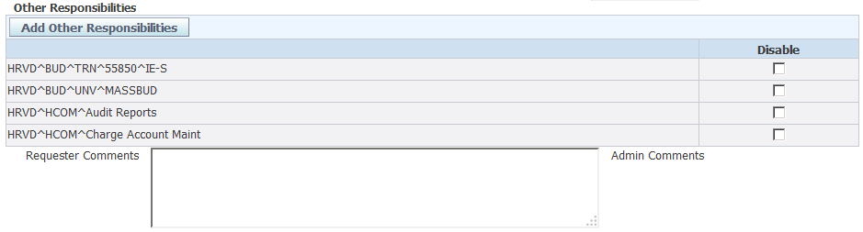
Enter your comments in the Requestor Comments field

If there are no further changes needed for this user, select one of the buttons at the top or bottom of the screen.
You have several options available to you.
  - If you wish to submit the request, click on the Submit Request button.
  - You can also choose to simply save the form, or Save and Return to the Security Form search screen.
  - You can also Return to the Search screen without saving, or Cancel the request.
  - In this example, Submit Request will be selected.

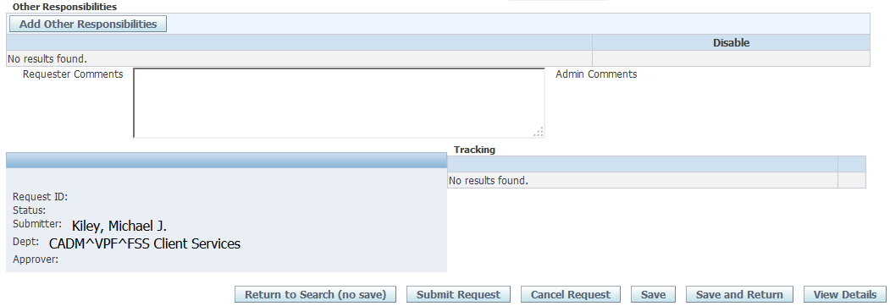

After you submit your request, a confirmation screen will appear.

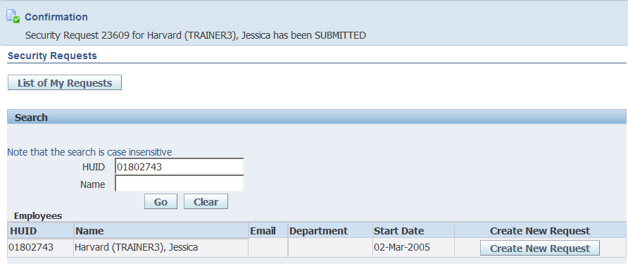

When your request for Reporting access has been completed, your user will be assigned the responsibility you requested.

- HRVD^FCOR^O30710n,R52480^BIE-S^X

Other examples of HDW Reporting responsibilities are …….

HDW^FCOR^O31560^F271219n1^BIE^P

HDW^HMS^O45300,A015559n^IE^P

HDW^HMS^O45300n^BFIE^P

HDW^SPH^A556491^BIE^P

HDW^KSG^R02100n^BIE-S^X

Note that HDW responsibilities have a letter before each CoA segment in the responsibility name. Since HDW responsibilities maybe be restricted on multiple CoA segments, the beginning letter of each segment (Org, Fund, Activity and Root) is included in the name to make the CoA segment for readily identifiable.

