Query Only Responsibility

HRVD^GL^UNV^QUERYONLY

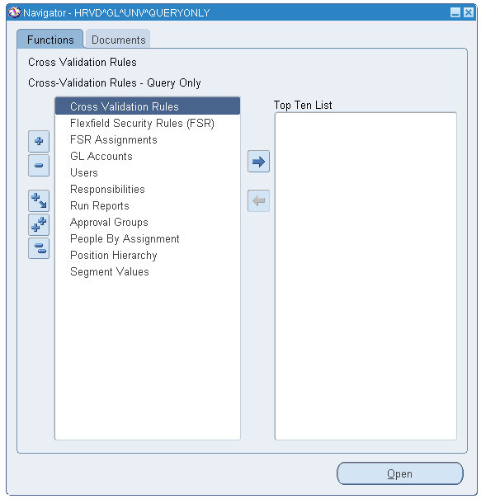

Query a User

Double click on Users or select Users and click the Open button.

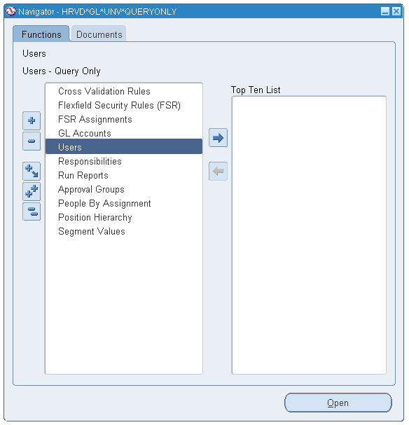

Press F11 or select from the toolbar View – Query By Example – Enter
Press CTRL F11 or select from the toolbar View – Query By Example – Run to execute the query. You may enter a User Name, Description or Person information to retrieve a user record

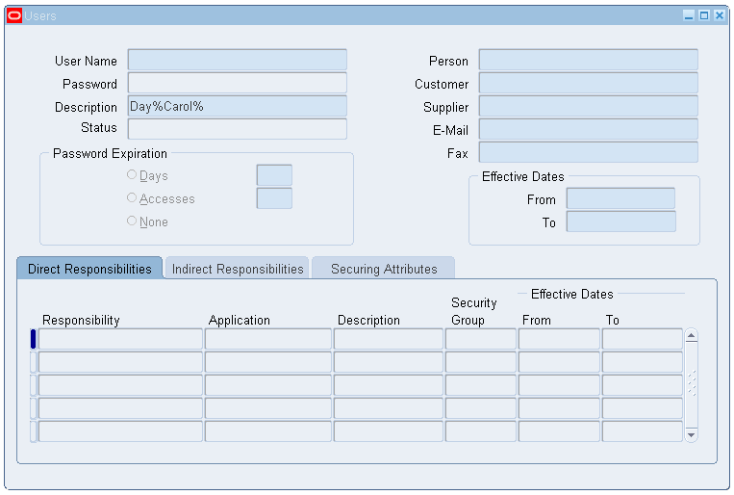

You can now view the Users full profile

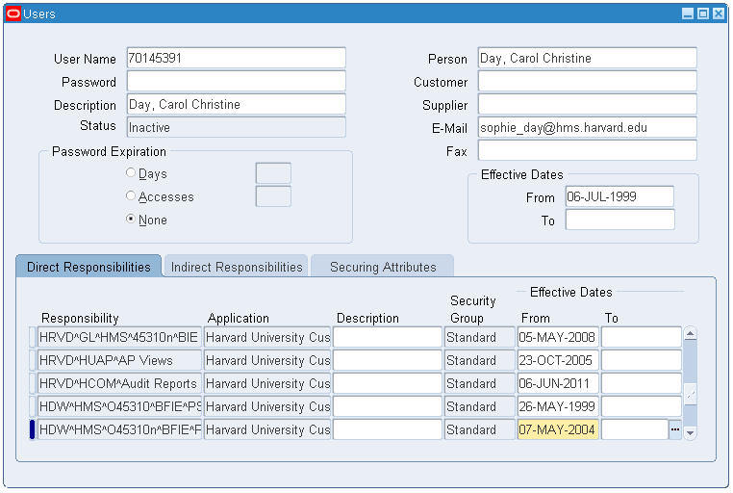

You can scroll through the list of the Users assigned responsibilities.

In the Responsibility section of the form, if the Effective To date is populated with a date less than or equal to the current date, then that responsibility is no longer available to the user.

If the Effective To date is populated with a date greater than the current date, then that responsibility will no longer be available to the user beginning on that date.

In the upper User section of the form the Effective From and To dates indicates the user active/inactive status.

The Effective From date indicates when the user was originally created.

If the Effective To date is empty, then the user is active.

If the Effective To date is populated with a date less than or equal to the current date, then the user is inactive.

If the Effective To date is populated with a date greater than the current date, then the user will become inactive on that date.

Query a Responsibility

Double click on Responsibilities or select Responsibilities and click the Open button.

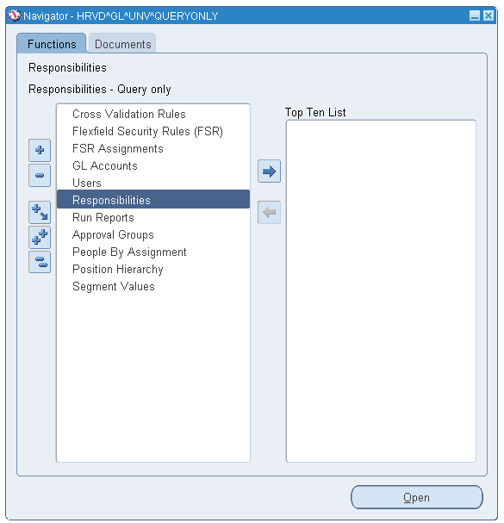

Press F11 or select from the toolbar View – Query By Example – Enter
Press CRTL F11 or select from the toolbar View – Query By Example – Run the query.
You may enter a Responsibility Name, or partial Responsibility Name, to retrieve information

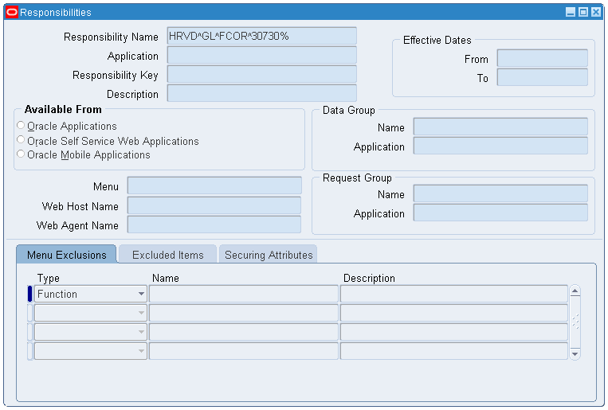
You can now view the full Responsibility record

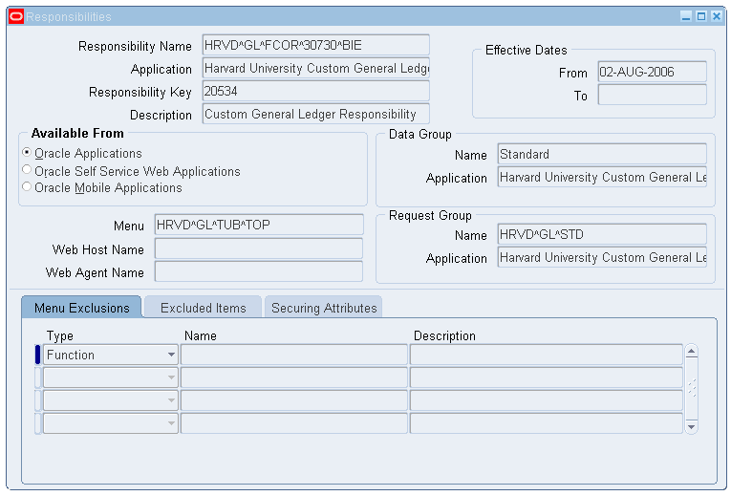

The Effective From and To dates indicates the Responsibility active/inactive status.

The Effective From date indicates when the Responsibility was originally created.

If the Effective To date is empty, then the Responsibility is active.

If the Effective To date is populated with a date less than or equal to the current date, then the Responsibility is inactive.

Flexfield Security Rules (FSRs)

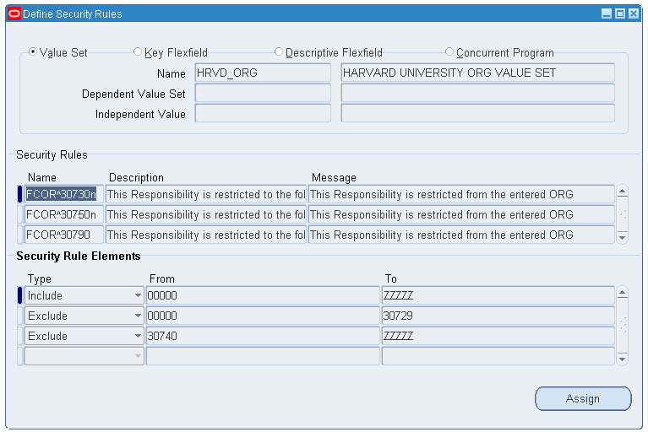

Flexfield Security Rule Assignments

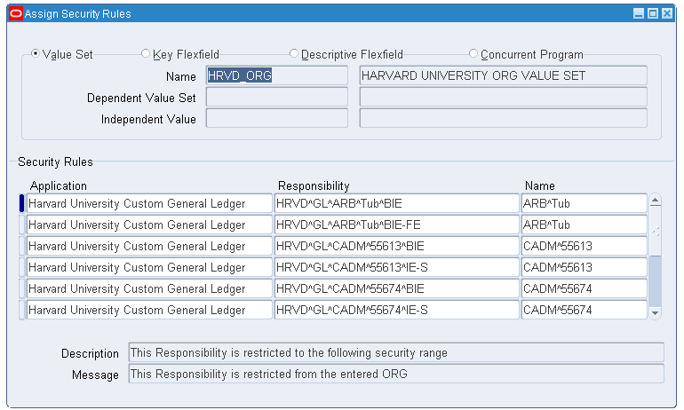

Web Voucher Approval Groups

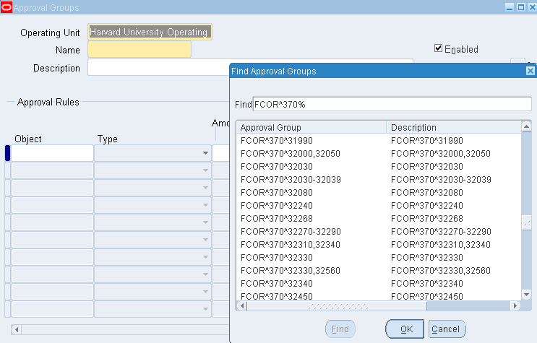

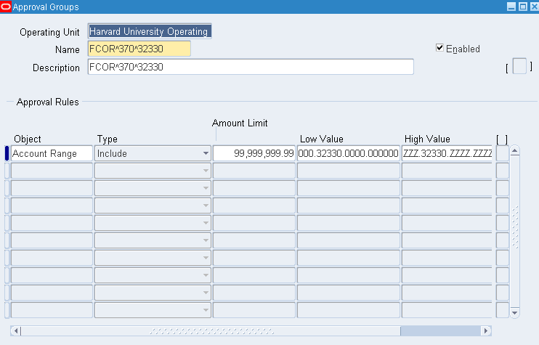

How to look up Chart of Accounts segment values

Double click on Segment Values or select Segment Values and click the Open button

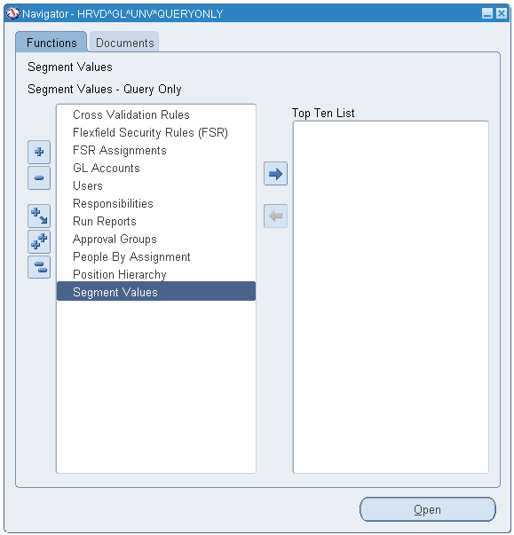

Enter the segment name you wish to search on. (HRVD_TUB, HRVD_ORG, HRVD_FUND, HRVD_ACTVITY, HRVD_ROOT) Click the Find button.

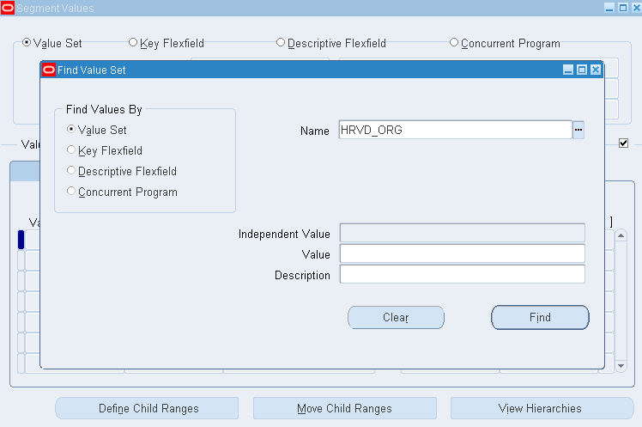

When you first click on the Find button, Oracle will display the entire list of values for the segment type you entered.

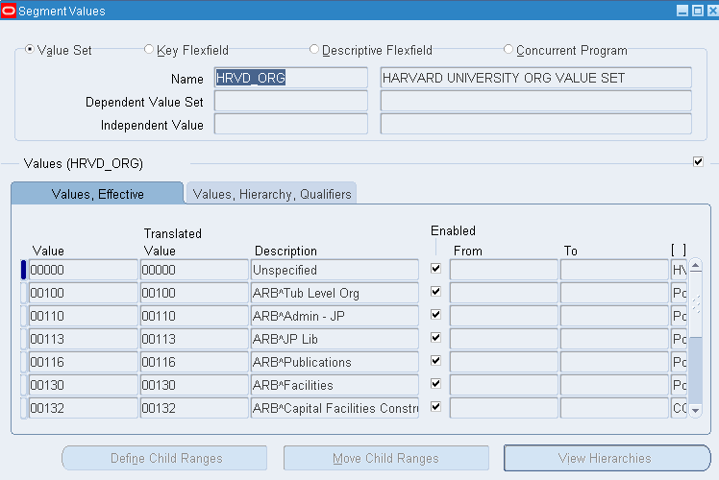

To limit the list of values, click in the Value field and press F11
In this example, enter 30% and press CRTL F11

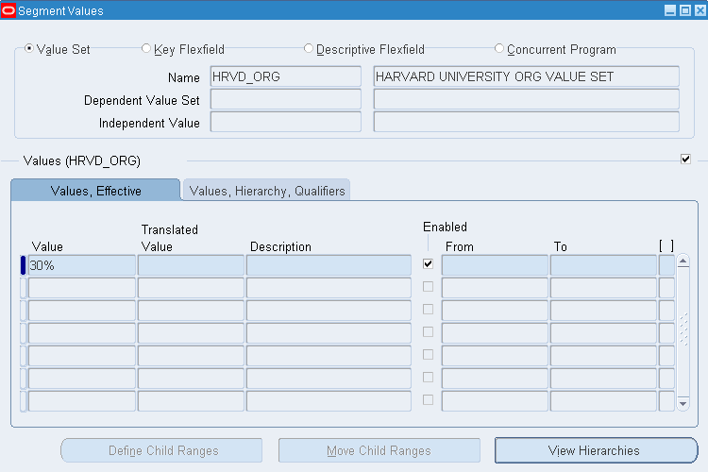

Oracle will now display all values that begin with 30

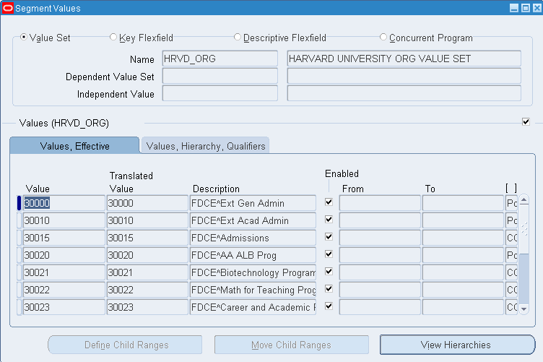

You may also search on Parent Values

In this example, click in the Value field and Press F11

Enter M3% and Press CTRL F11

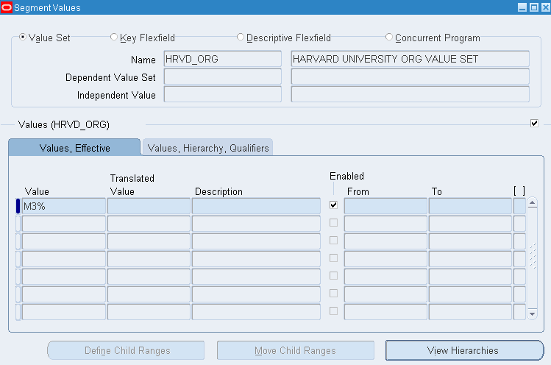

Oracle will display a list of all Mega Org Parents that begin with M3

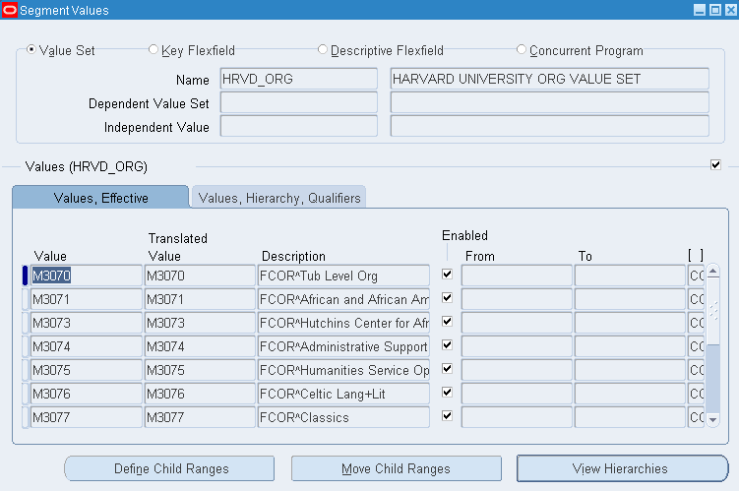
How to look up 33 digit Chart of Accounts Code Combinations (CCID)

Double click on GL Accounts or select GL Accounts and click the Open button

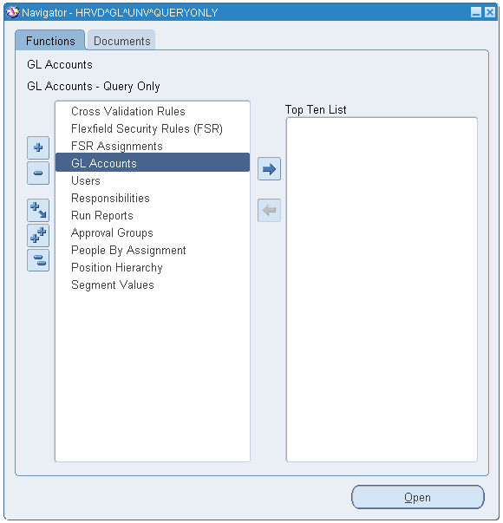

This will open the GL Accounts form

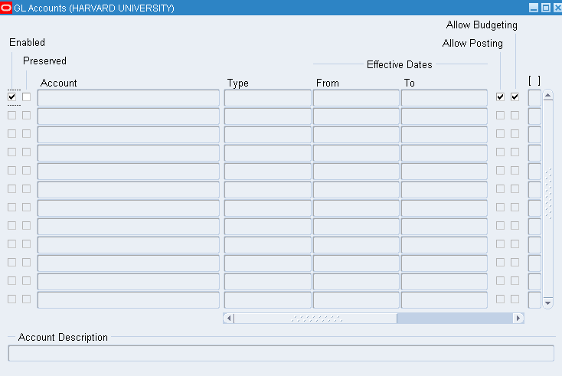
To find GL accounts, from the Oracle toolbar click on View – Find, or click the flashlight icon and enter the values you wish to search on.

In this example, we will look for any GL account containing Org 30700 and Object Code 6640

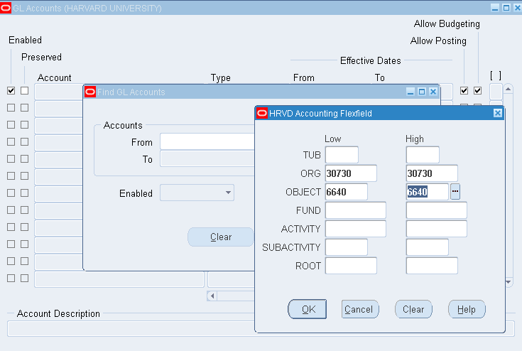

Click the OK button, then click the Find button

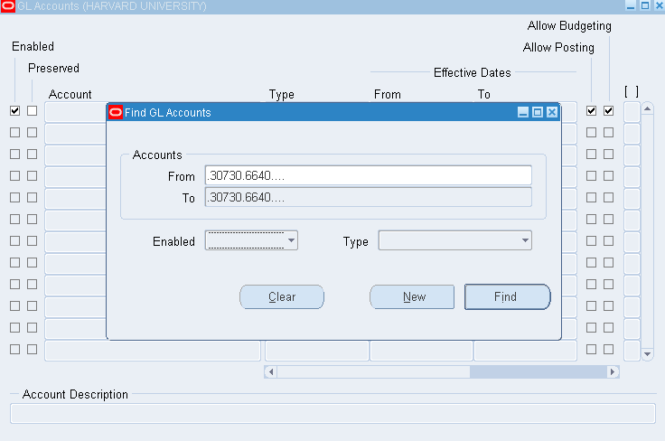
Oracle will now display a list of all GL Accounts (CCIDs) that contain Org 30700 and Object Code 6640

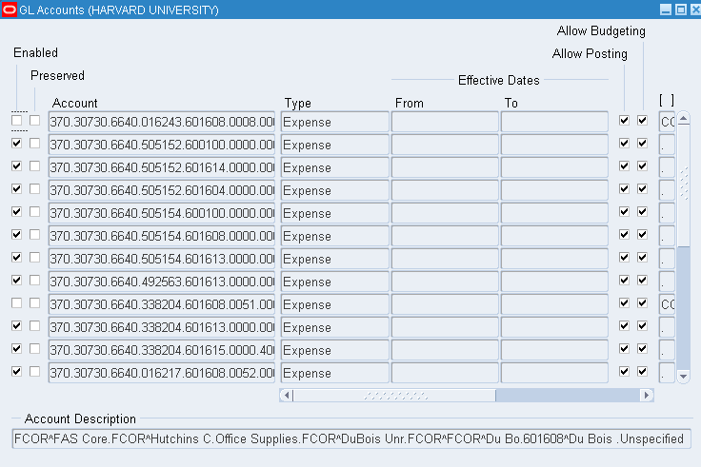

What Chart of Accounts values does my Responsibility have access to?

Run the HU FSR Assignment Detail Listing Report to see the Chart of Accounts values associated with a Responsibility.

Run Reports

Double click on Budget Domain or select Budget Domain and click the Open button

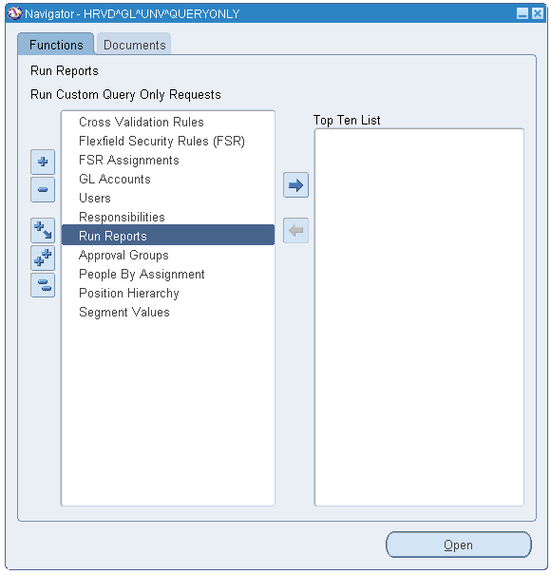

Select OK to run a single request.

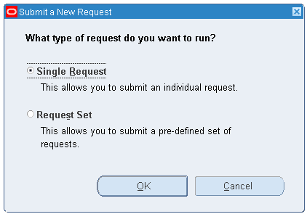

Submit Request window opens

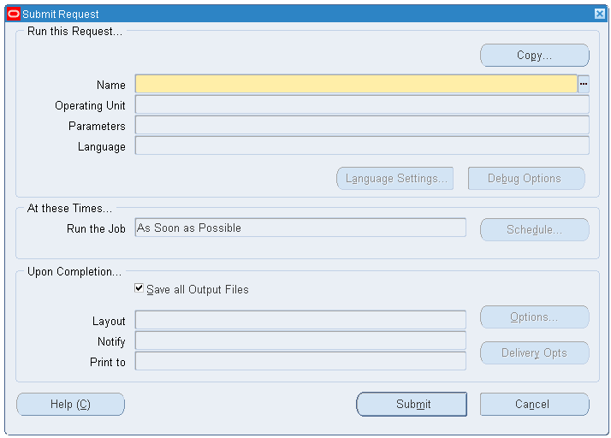

Press CTRL L to see a list of available reports

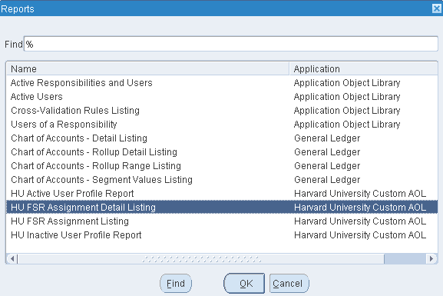

Select HU FSR Assignment Detail Listing and click the OK button

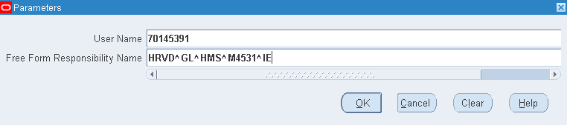

Enter the User Name and Responsibility Name and click the OK button.

If you leave the User Name field empty, you will return every user who is assigned the responsibility you entered.

If you leave the Responsibility Name field empty and enter only a User Name, you will return results for every Responsibility assigned to the user.

Click the Submit button.

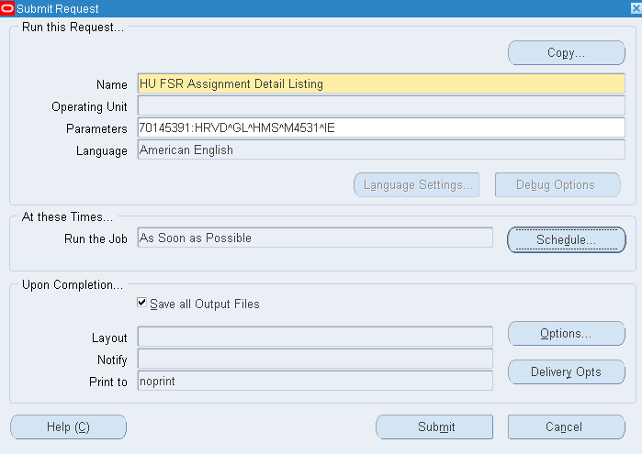

When the request is completed, click on View Output to see results.

