In this section, you will learn how monitor the status of user security requests you have submitted.

Log into Oracle and select your HRVD^SECURITY^REQUESTOR responsibility. To view a list of your user security requests, click on the List of My Requests button.

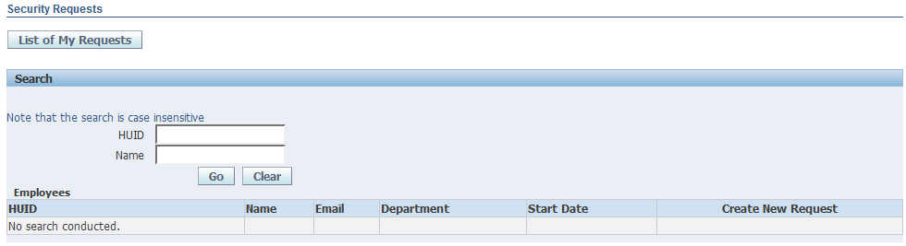

In the new window that opens, you can view a list of all your requests.

You may click on any of the column headers, like Request ID, Name, HUID, etc, to sort your requests as needed.

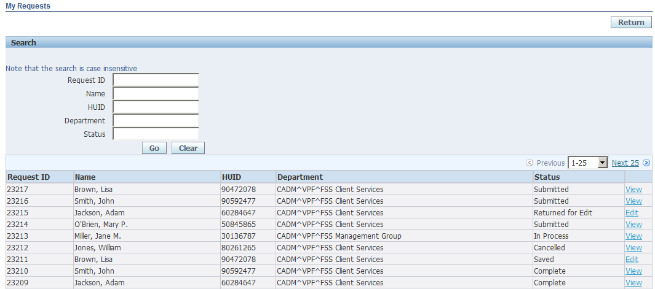
Click on the column headers to sort requests

Request Statuses

Your request may have any of the following statuses.

- Submitted – requests you have submitted but have not yet been completed by Client Services
- In Process – requests that Client Services have begun processing, but have not yet completed
- Complete – requests completed by Client Services
- Returned for Edit – a request Client Services has sent back to you for changes
- Saved – requests you have started and saved, but have not yet submitted
- Cancelled – requests cancelled by yourself or Client Services

Note that for Saved requests, you can click the Edit link to open the request, make any additional changes, and then submit your request.

A request will have a status of Returned for Edit when Client Services has sent the request back to the submitting Authorized Requestor for changes. Client Services will include comments identifying the required changes in the Admin Comments field. Click on the Edit link to open the request, view comments, make any necessary changes and resubmit the request.

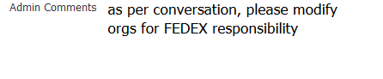

For Cancelled requests, Client Services will only cancel a request after notifying the Authorized Requestor the reason for cancelation, or when specifically asked to cancel a request by an Authorized Requestor. Once a request has been cancelled, it can no longer be edited or resubmitted. A new request must be created.

An Authorized Requestor can also cancel a request, but only when its status is still listed as Submitted. Once a request is either In Process or Complete, it cannot be cancelled.

To Cancel a Submitted request, click on the View link to open the request, and click the Cancel Request button.
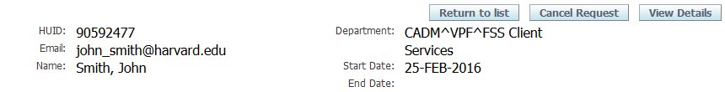

You will receive a Warning message asking you to confirm cancelation. Click Yes to continue.

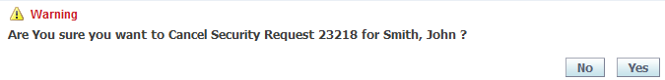

Your request now has a status of Cancelled.

Viewing Requests

You may view the detail of a request at any time regardless of status.

In the My Requests window, click on the View link to open any request.

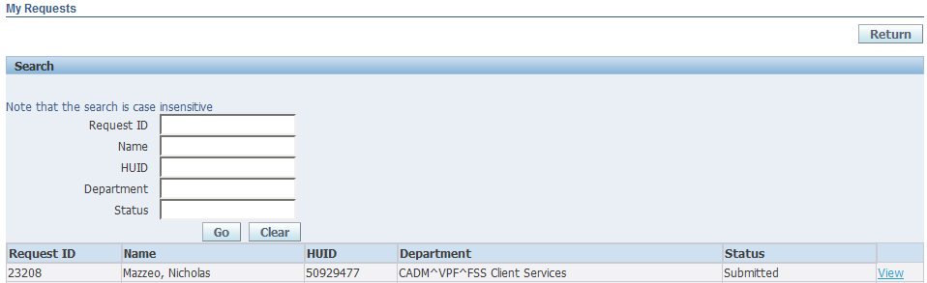

The full request window will open showing all the users current access. Those responsibilities displayed with an asterisk (*) are the newly requested responsibilities.

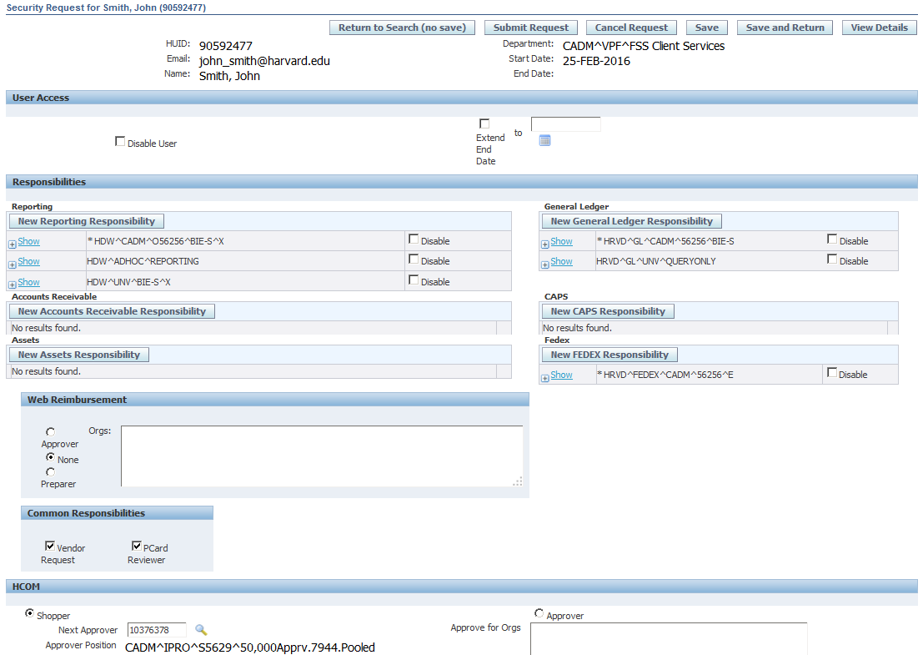

Click on the View Details button at the top right of the screen to see a summarized view of your request

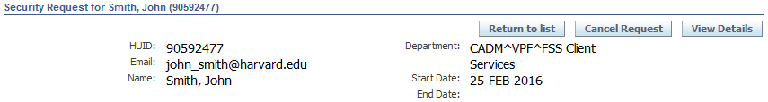

Summarized view

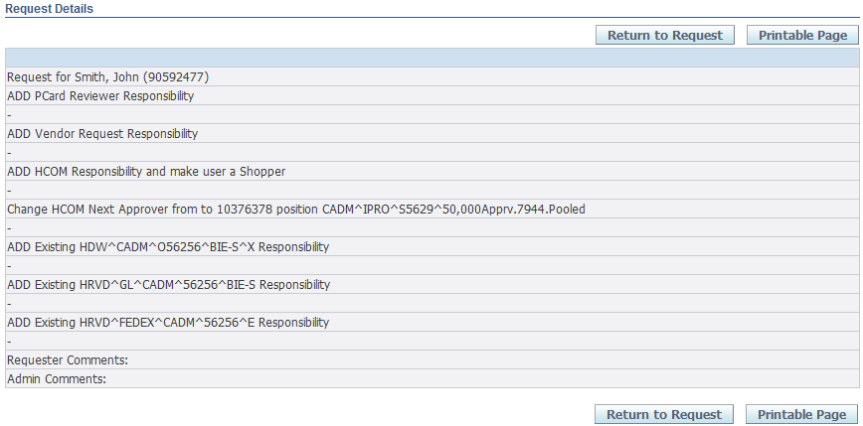

Click the Printable Page button if you wish to save a paper copy for your records.

If you have any questions regarding user security requests, you can contact Client Services at
FSS_Client_Services@harvard.edu

