In this section, you will learn about the Oracle User Security Request form, how to open a new request and descriptions for each section of the form.

If your School or unit has designated you as an Authorized Requestor of Oracle user security, and you have completed the required training, then you will be assigned the HRVD^SECURITY^REQUESTOR responsibility in Oracle.

Log into Oracle and click on the responsibility on your Oracle home page.

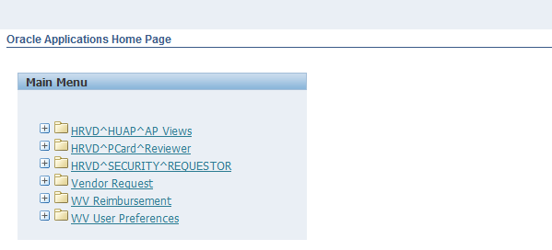
Click on the
Security Requestor responsibility

In the new window that opens, you can search for an employee by entering their Harvard ID in the HUID field or by their employee name in the Name field.

In the Name field, you can enter a partial name with a % sign to pull up a list of all employees with a similar name. In this example we have entered Smith%. Click the Go button.

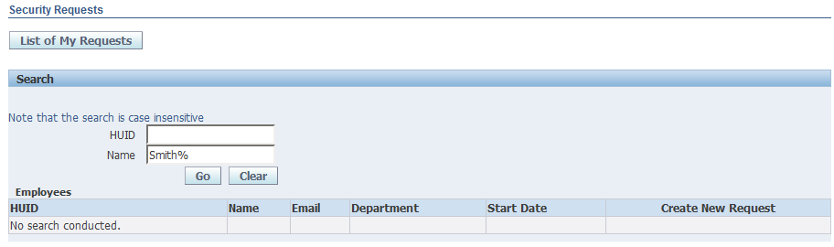

A list of potential matches will be displayed. Find your employee and click on the Create New Request button to open the User Security Request form.

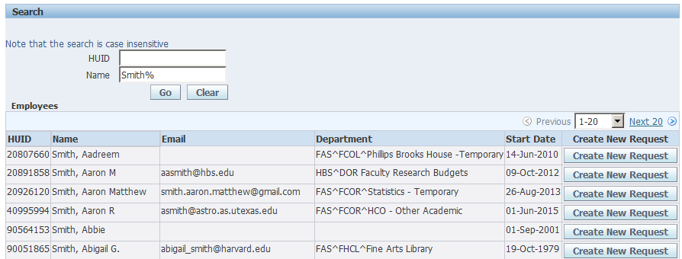
Included here is the full User Security Request form with descriptions of each section of the form.

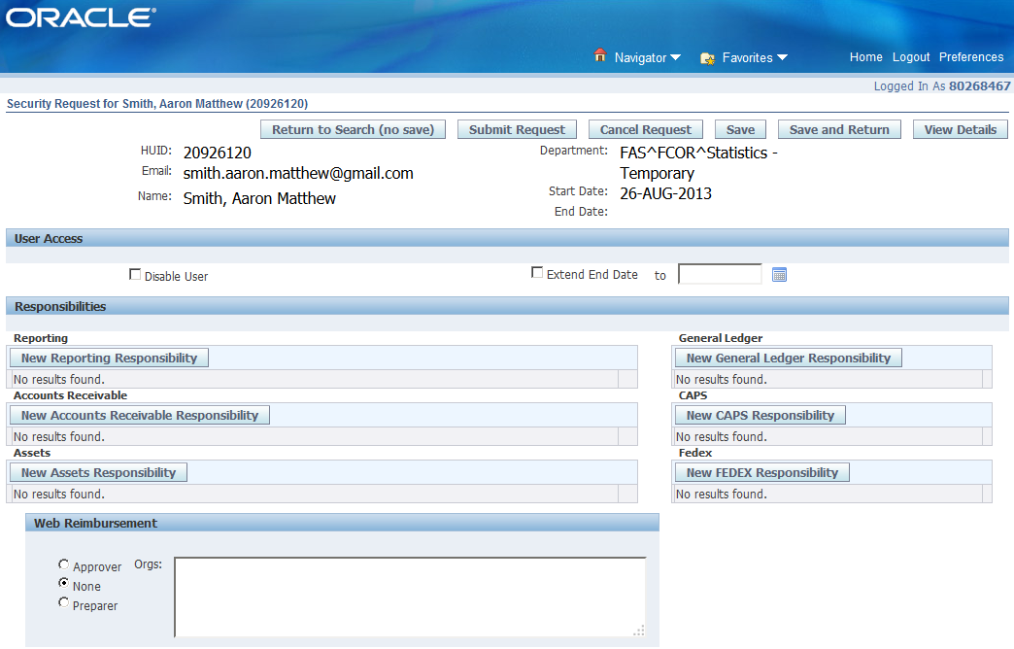
2
9
8
7
6
5
4
3
1
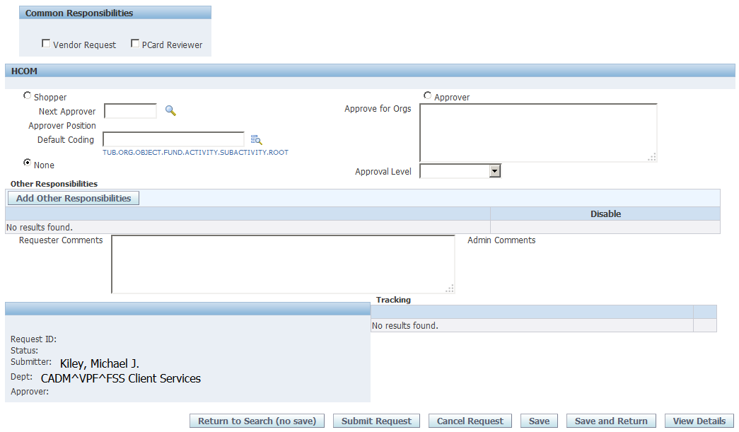
14
13
12
10
11

1-Form Header - The first section of the form displays details for the employee you selected, including: HUID, Department, Name, Employment Start Date, and, if applicable, End Date.

2-User Access – In this section you can disable a user and all their access by checking the Disable User checkbox. If the user is a temp or consultant, you can extend their access by checking the Extend End Date checkbox and entering a new end date “to” date field.

3-New Reporting Responsibility – For detailed instructions on creating a new reporting responsibility, please refer to the Oracle User Access section of the FSS Client Services site.

4-New Accounts Receivable Responsibility – For detailed instructions on creating a new Accounts Receivable responsibility, please refer to the Oracle User Access section of the FSS Client Services site.

5-New Assets Responsibility – For detailed instructions on creating a new Assets responsibility, please refer to the Oracle User Access section of the FSS Client Services site.

6-New General Ledger Responsibility – For detailed instructions on creating a new General Ledger responsibility, please refer to the Oracle User Access section of the FSS Client Services site.

7-New CAPS Responsibility – For detailed instructions on creating a new CAPS responsibility, please refer to the Oracle User Access section of the FSS Client Services site.

8-New FEDEX Responsibility – For detailed instructions on creating a new FEDEX responsibility, please refer to the Oracle User Access section of the FSS Client Services site.

9-Web Reimbursement – For detailed instructions on assigning the Web Reimbursement responsibility, please refer to the Oracle User Access section of the FSS Client Services site.

10-Common Responsibilities – For detailed instructions on assigning common responsibilities, please refer to the Oracle User Access section of the FSS Client Services site.

11-HCOM – For detailed instructions on assigning HCOM access, please refer to the Oracle User Access section of the FSS Client Services site.

12-Add Other Responsibilities – For detailed instructions on assigning other responsibilities, please refer to the Oracle User Access section of the FSS Client Services site.

13-Requestor Comments – Use this section of the form to add any clarifying comments or other useful information that will assist Client Services with processing your request.

14-Form Footer – The left side of the footer will contain the Request ID, the name and department of the person submitting the form and the Approve name, which is the Clients Services staff member who completed the request. The right side of the footer will contain date stamp information when the request was submitted and when it was processed.

If you have any questions or need additional information on the Oracle User Security Request Form, contact Client Services at FSS_Client_Services@harvard.edu

