In this section, you will now learn how to search for, edit, create and disable Fixed Assets responsibilities on the Oracle Online User Security Request Form.

Fixed Assets, one of the modules within Harvard’s Oracle financial applications, allows for the financial management of assets, simplifies accounting tasks and provides visibility into assets across the University. The system automates transactions, captures and tracks equipment attributes, supports federal and non-federal award compliance, supports multiple deprecation methods while providing reporting and the ability to review asset details.

To add a new responsibility, click on the New Assets Responsibility button.

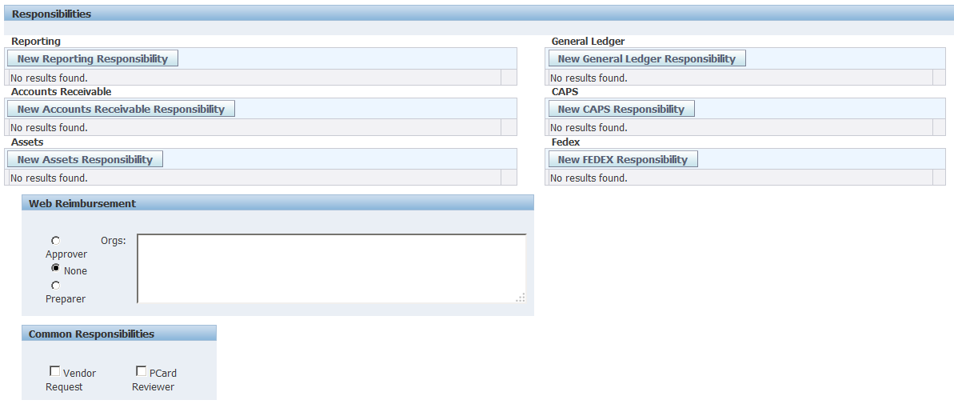

In the new window that opens, you can search for existing Fixed Assets responsibilities.

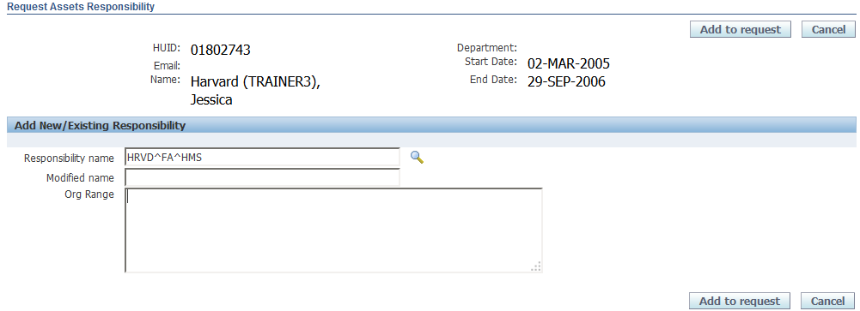
Then click the flashlight icon
To see a list of all current Assets responsibilities:
- Type in the letters HRVD, followed by a caret (^)
- Type the acronym FA, followed by a caret
- Type the 3 or 4 letter acronym for the school or unit

To select an existing responsibility, click on the Radio button in the Select column
Then click the Select button.
- Easier: click the Quick Select icon to select the value.

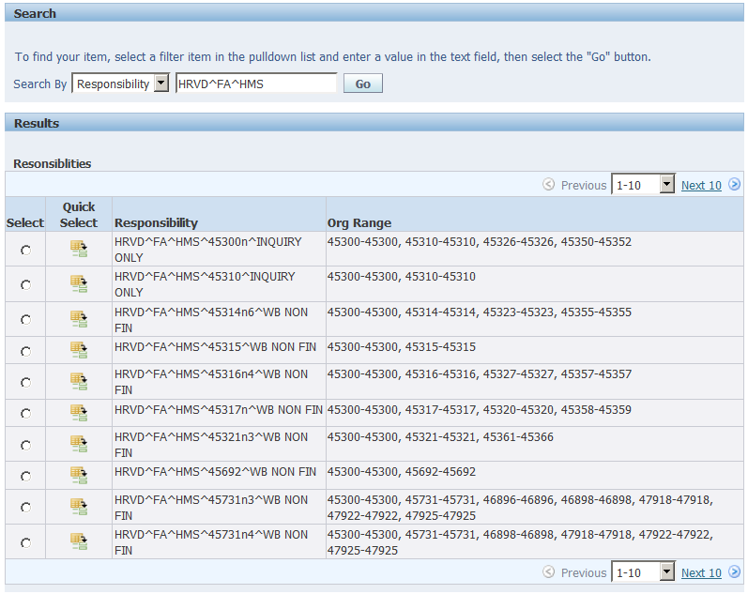

A list of values matching the search criteria will appear on the screen.
- The list begins with the FA responsibility. An additional column displaying the Org Range will appear to the right of the responsibility.
- If there are more than 10 entries on the list, a Next 10 Link will appear on the screen that will allow you to view additional responsibilities. In this example, there are only four existing responsibilities for this school.

You will be returned to the Request Assets Responsibility screen and the selected Responsibility Name and Org Range will appear.

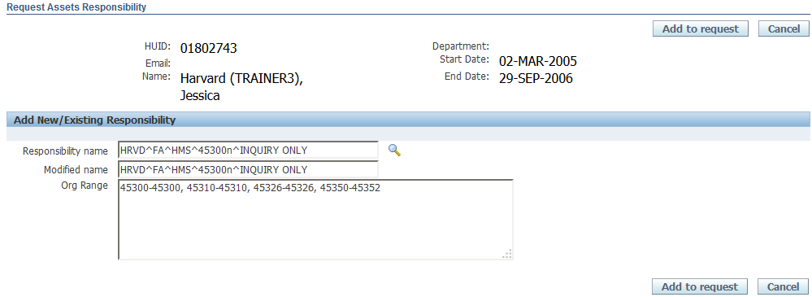

To add this existing responsibility to your user, simply click on the Add to Request button.

To create a new Fixed Assets responsibility for this user, you can use this existing responsibility and modify it to meet your user's needs.
In this example:
  - The Org value will be replaced with a new value.
  - The Org values represented by the new Org will be entered into the Org Range field.
Once these values have been changed, click on the Add to Request button.

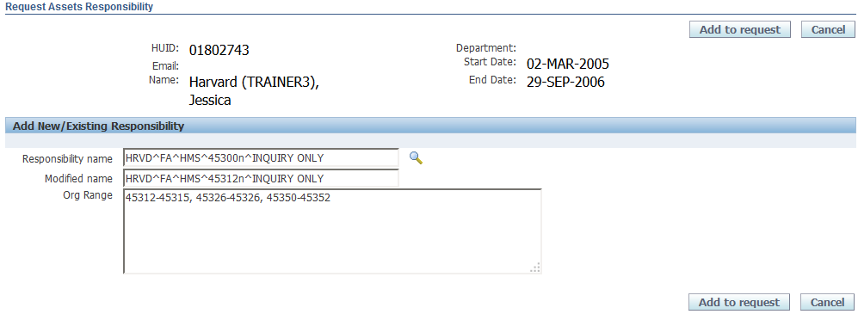
Enter the modified org range in the Org Range field
Change the org value in the Modified name field

You will return to the Security Form. The responsibility will appear in the Assets Section.
  - Note the asterisk to the left of the requested responsibility. This means that you have added a request but it has not yet been submitted for approval.
  - Click on the Show link to see more details about this responsibility.

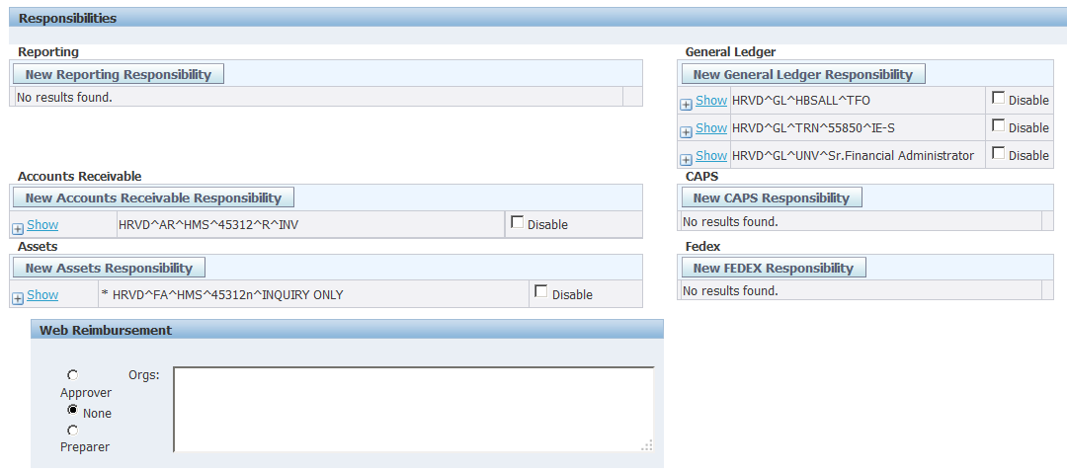

The information regarding the Org Ranges will appear.
  - Close these details by clicking on the Hide link.

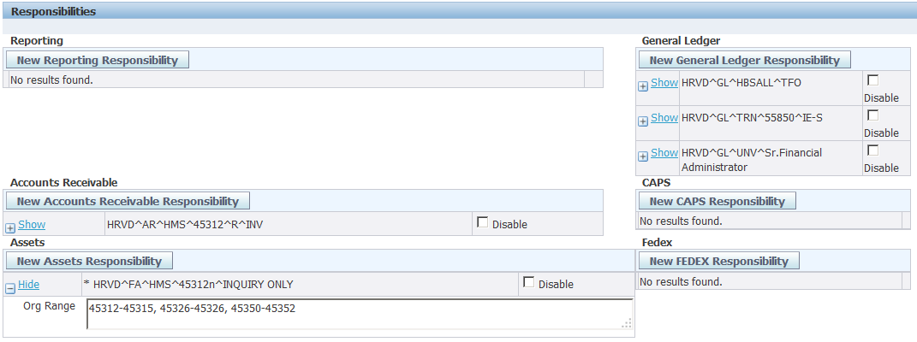

After the request is submitted and approved, this responsibility will be added to the user's security profile.
  - If at any time I want to disable this user's access, you can simply check off the Disable checkbox.
  - If the user leaves the position and/or the University, you can disable all Oracle and Reporting privileges by selecting the Disable User checkbox under the User Access heading.

Disable the user and all their access
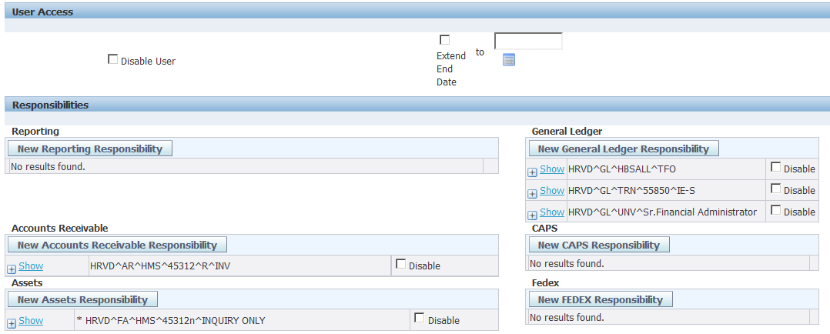
Or just disable a responsibility

If you wish to add notes about this request to the FSS Client Services Team, scroll down to the bottom of the screen and add your comments in the Comments field.

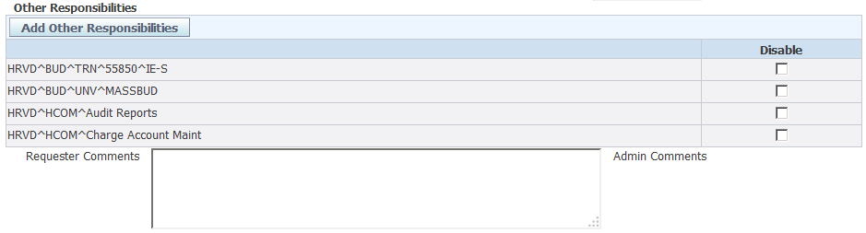
Enter your comments in the Requestor Comments field

If there are no further changes needed for this user, select one of the buttons at the top or bottom of the screen.
You have several options available to you.
  - If you wish to submit the request, click on the Submit Request button.
  - You can also choose to simply save the form, or Save and Return to the Security Form search screen.
  - You can also Return to the Search screen without saving, or Cancel the request.
  - In this example, Submit Request will be selected.

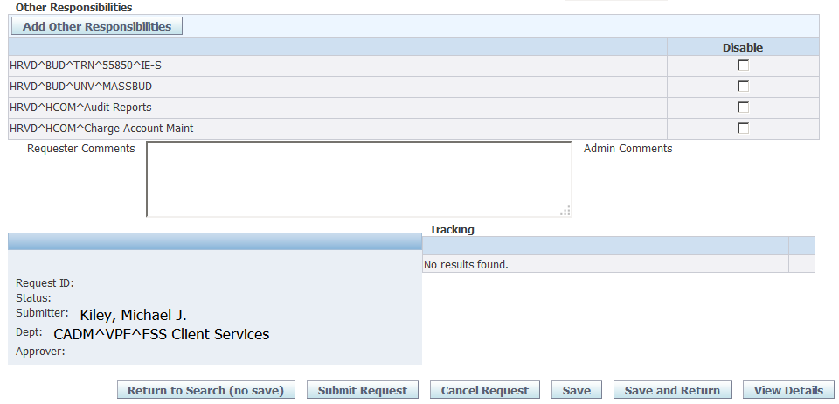

After you submit your request, a confirmation screen will appear.

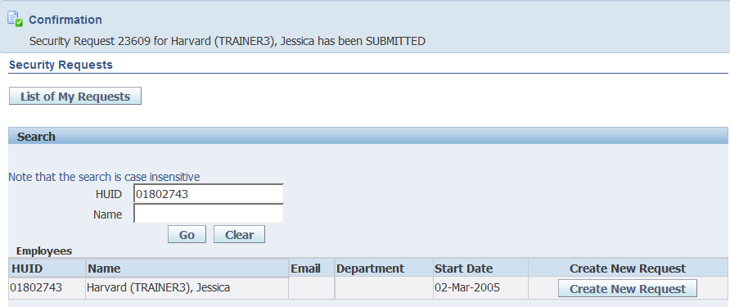

When your request for Fixed Assets access has been completed, your user will be assigned the responsibility you requested.

- HRVD^FA^HMS^45312n^INQUIRY ONLY

In addition to the Inquiry only responsibility example used for these instructions, there are a number of other Fixed Assets responsibilities that can be assigned to a user. These responsibilities allow users to prepare Mass Additions, access to the Assets Workbench, physical inventory functionality, as well as the ability to submit and approve AP adjustments.

