In this section, you will now learn how to search for, edit, create and disable CAPS access on the Oracle Online User Security Request Form.

The Capital Projects Services application (CAPS) is a web-based approval workflow system for capital construction projects. All Harvard Schools or units planning a capital project with costs of $100,000 or more must get the project approved prior to beginning the planning or construction

There are two CAPS roles relevant to schools/units:
- Preparer: School or unit project manager (or designee) responsible for initiating and inputting data into CAPS Project Proposals, Construction Authorizations and Construction Close Requests. This role can also create Detailed Project Budgets.
- Requestor: School or unit project manager or financial officer (or designee) responsible for submitting (and in some cases preparing) CAPS Project Proposals, Construction Authorizations and Construction Close Requests for approval.

To add a CAPS responsibility to a user, navigate to the CAPS section of the User Security Request form and click on the New CAPS Responsibility button.

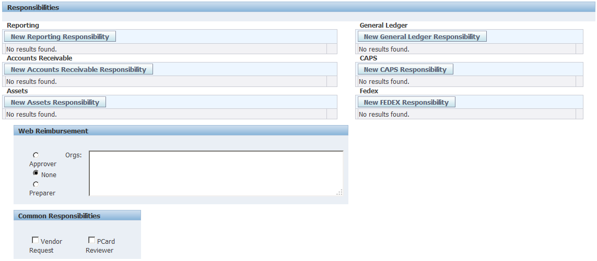

In the new window that opens, you can search for existing CAPS responsibilities.

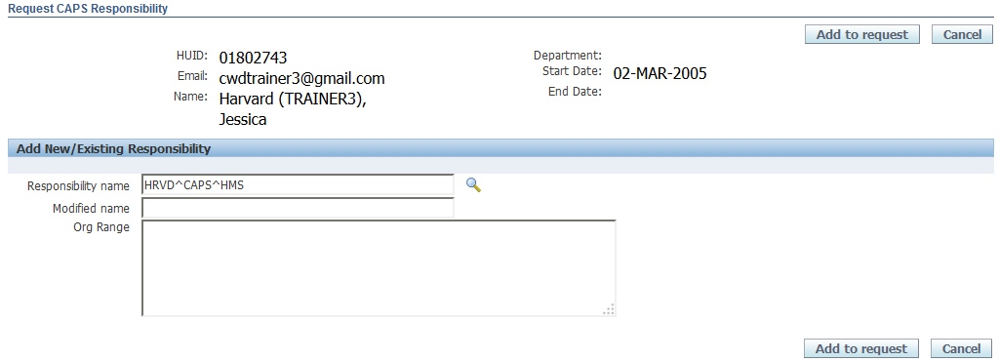
Then click the flashlight icon
To see a list of all current AR responsibilities:
- Type in the letters HRVD, followed by a caret (^)
- Type the acronym CAPS, followed by a caret
- Type the 3 or 4 letter acronym for the school or unit

To select an existing responsibility, click on the Radio button in the Select column
Then click the Select button.
- Easier: click the Quick Select icon to select the value.

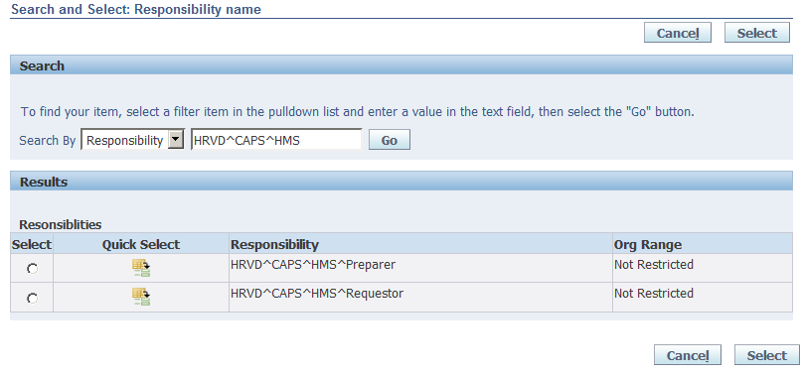

A list of values matching the search criteria will appear on the screen.
- The list begins with the CAPS responsibility name. Not Restricted will always be listed in the Org Range column for CAPS responsibilities as they are restricted at the Tub level only.
- If there are more than 10 entries on the list, a Next 10 Link will appear on the screen that will allow you to view additional responsibilities.

After selecting a responsibility, you will be returned to the Request CAPS Responsibility screen where the selected Responsibility Name will appear.

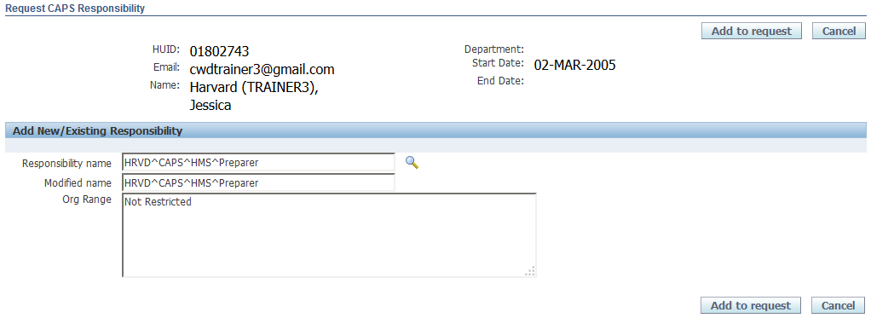

To add this existing responsibility to your user, simply click on the Add to Request button.

You will return to the User Security Form. The responsibility will appear in the CAPS section.
  - Note the asterisk to the left of the requested responsibility. This means that you have added a request but it has not yet been submitted for approval.
  - Click on the Show link to see more details about this responsibility.

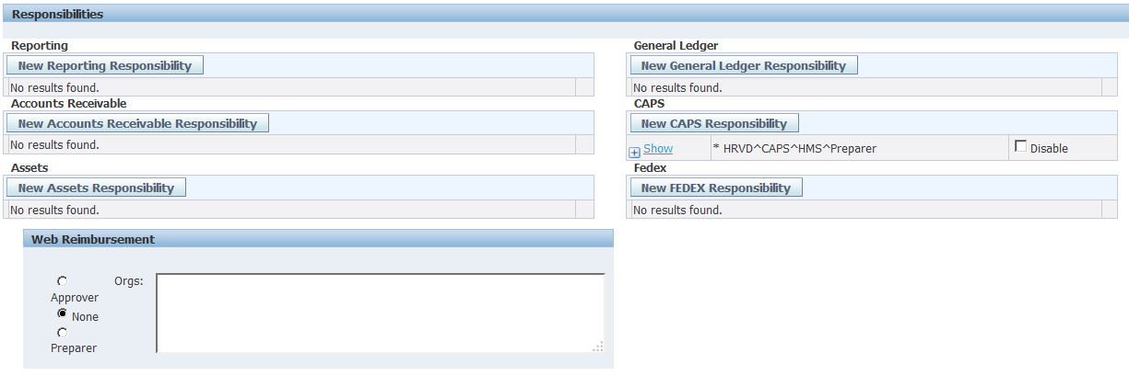

Close these details by clicking on the Hide link.

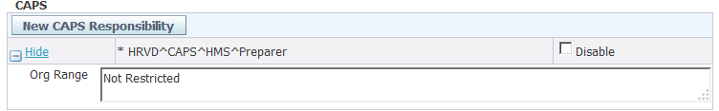

After the request is submitted and approved, this responsibility will be added to the user's security profile.
  - If at any time I want to disable this user's access, you can simply check off the Disable checkbox.
  - If the user leaves the position and/or the University, you can disable all Oracle and Reporting privileges by selecting the Disable User checkbox under the User Access heading.

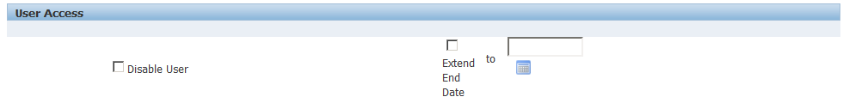
Disable the user and all their access
Or just disable the responsibility
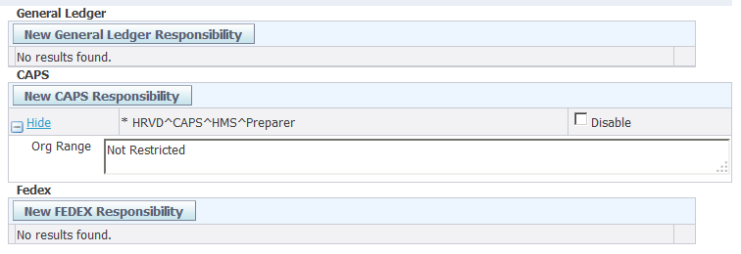

If you wish to add notes about this request to the FSS Client Services Team, scroll down to the bottom of the screen and add your comments in the Comments field.

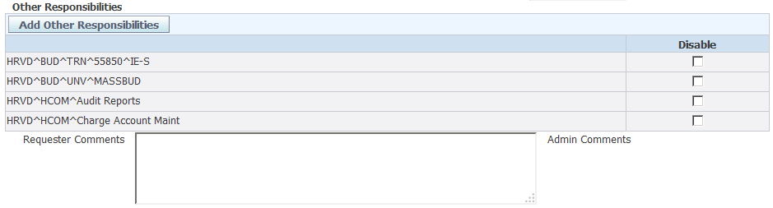
Enter your comments in the Requestor Comments field

If there are no further changes needed for this user, select one of the buttons at the top or bottom of the screen.
You have several options available to you.
  - If you wish to submit the request, click on the Submit Request button.
  - You can also choose to simply save the form, or Save and Return to the Security Form search screen.
  - You can also Return to the Search screen without saving, or Cancel the request.
  - In this example, Submit Request will be selected.

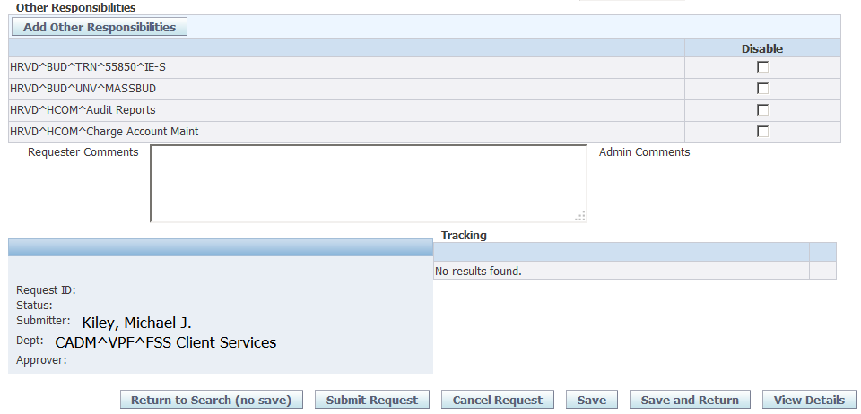

After you submit your request, a confirmation screen will appear.

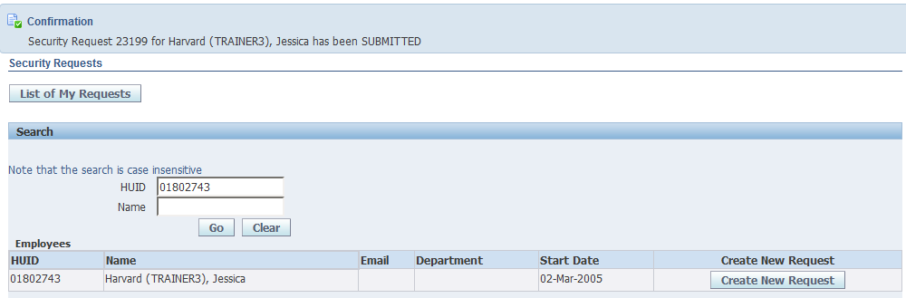

When your request for CAPS access has been completed, your user will be assigned the responsibility you requested,

- HRVD^CAPS^HMS^Preparer

Additionally there are CAPS Approver and Interested Party roles relevant to Central Administration users only.

- Approvers: Central Administration groups responsible for approving forms such as the CAPS Office, Office of Financial Strategy and Planning, Office of Treasury Management, Vice President of Finance, etc

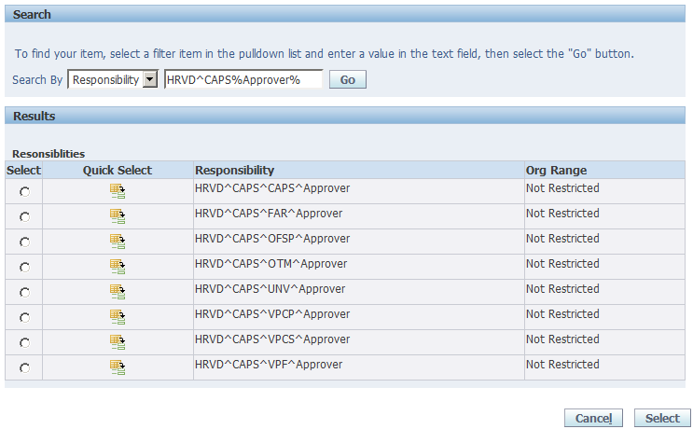

- Interested Parties: Stakeholders who need to be informed regarding CAPS projects, e.g., Environmental Health & Safety (EH&S), University Operations Services (UOS), etc. A request is available for review by Interested Parties when it is submitted to Central Administration (CADM).

